**Deploy Application on Cloud**

**OUPUT SCREEN**

1. **Instance List**

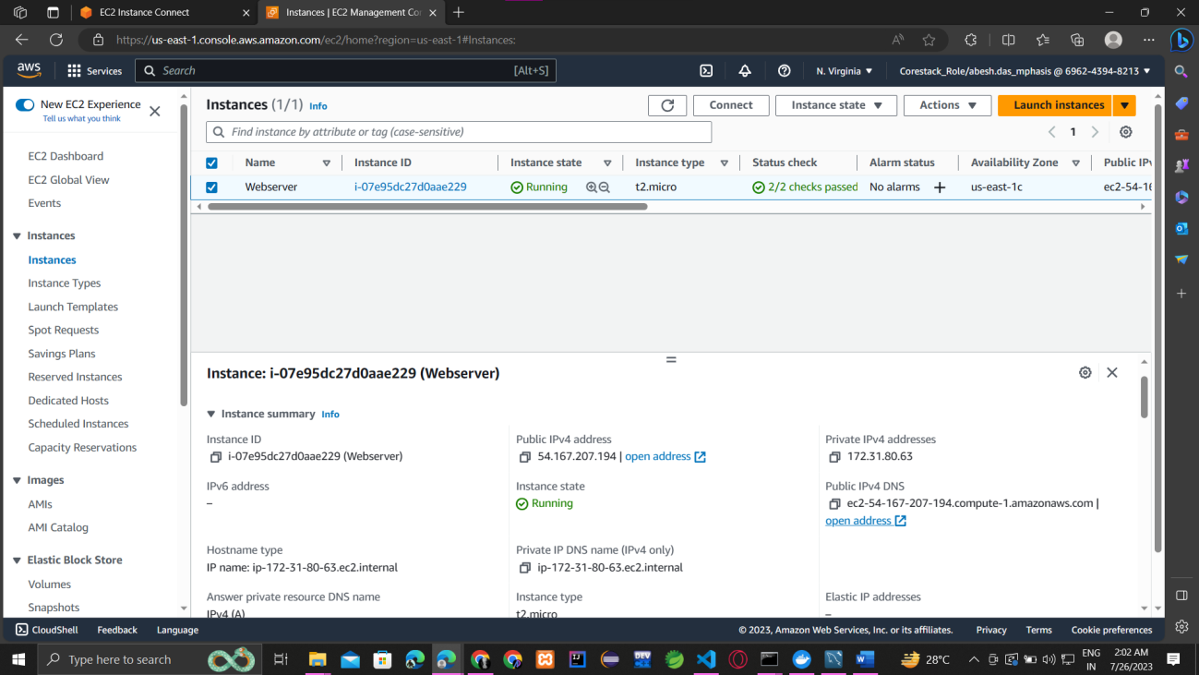

1. **Instance Live Link**

**Link : htp://ec2-54-167-207-194.compute-1.amazonaws.com:8080/**

